2 -
What is the difference between cat and more command?
cat :It displays a file one screen (page) at a time
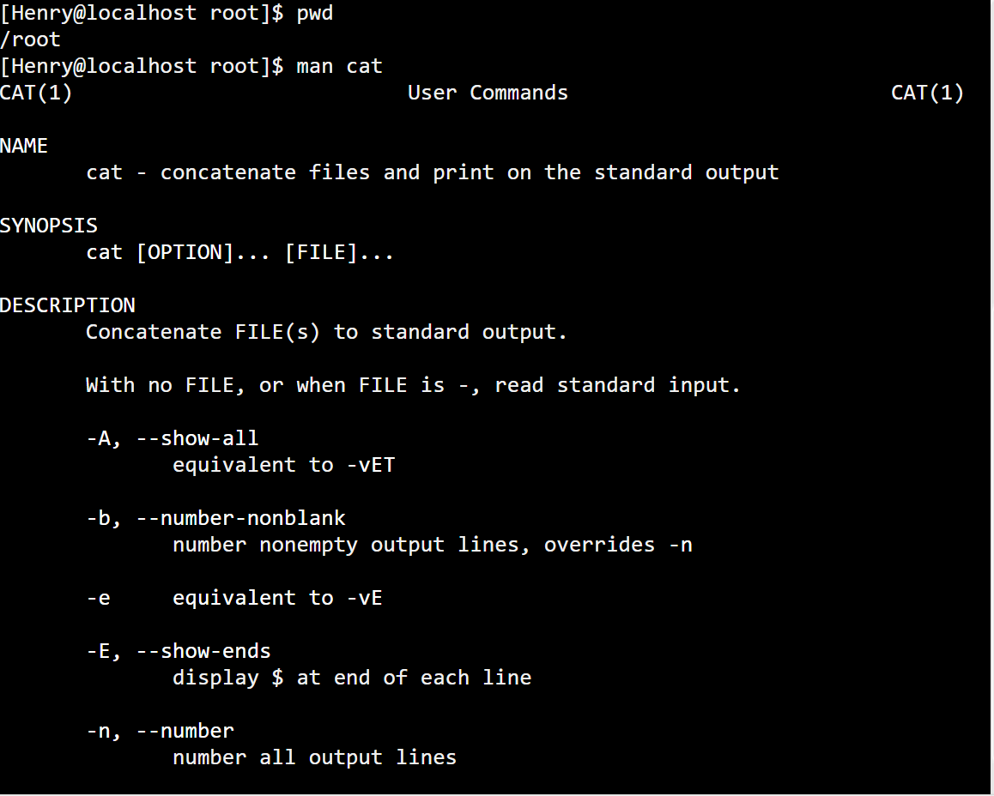
more: show content page-by-page
less : Similar to more, but more powerful and flexible
can search by /
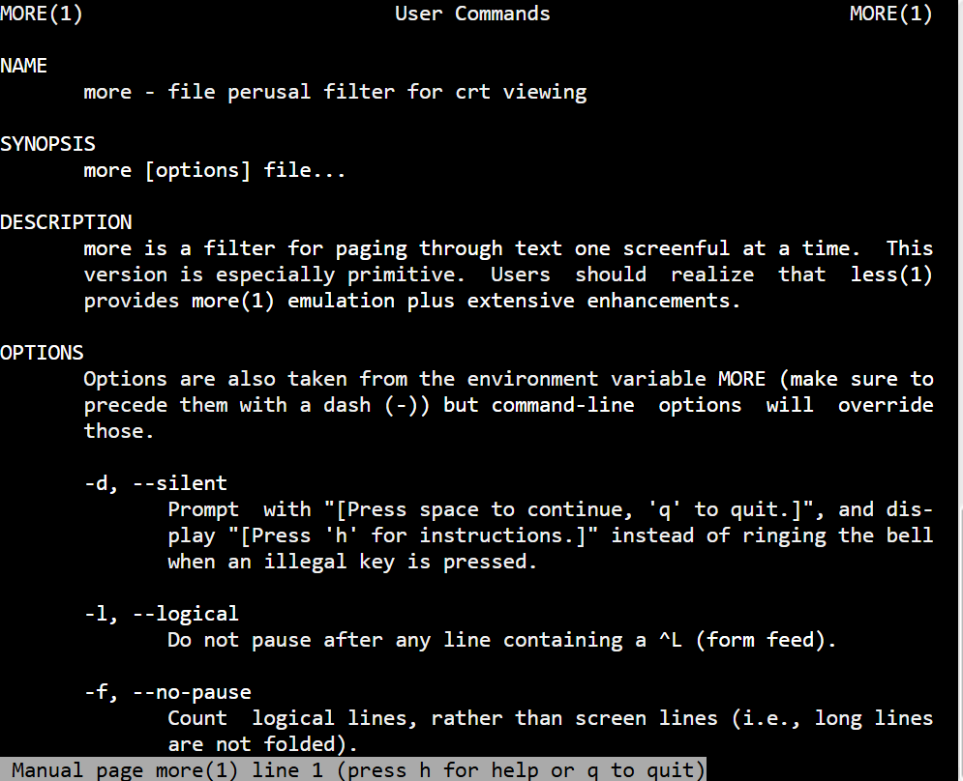
3. What is the difference between rm and rmdir using man?
rm : Remove empty or directories have files and files
rmdir : Remove only empty directories
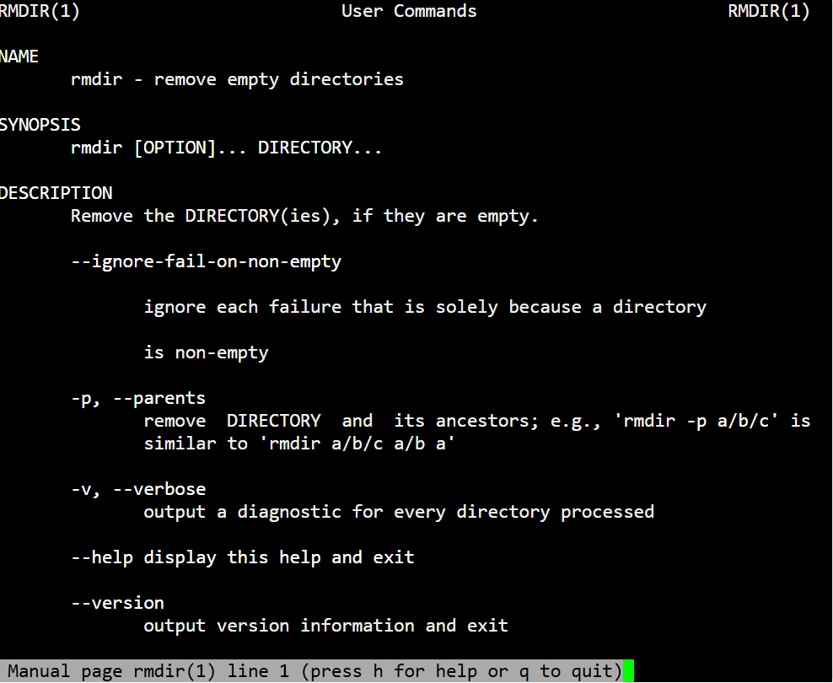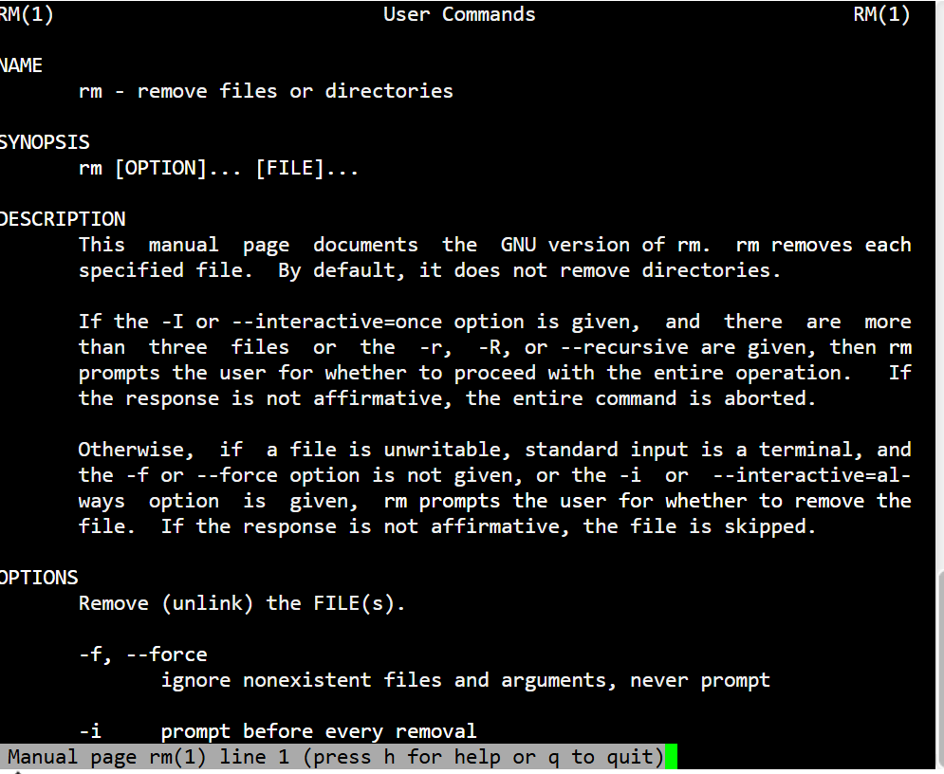
4. Create the following hierarchy under your home directory:
a -
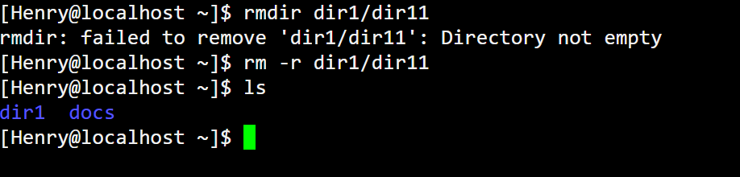
b-

c-

5. Copy the /etc/passwd file to your home directory making its name is mypasswd
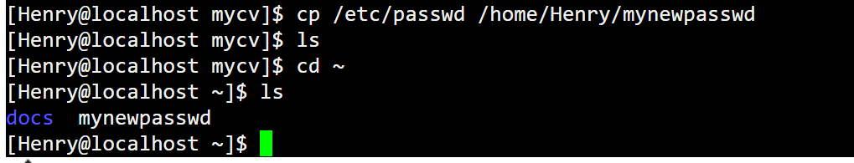
6. Rename this new file to be oldpasswd.

7. You are in /usr/bin, list four ways to go to your home directory
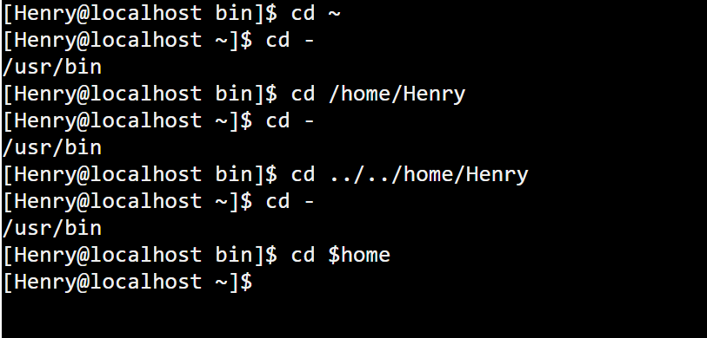
9. Display the first 4 lines of /etc/passwd
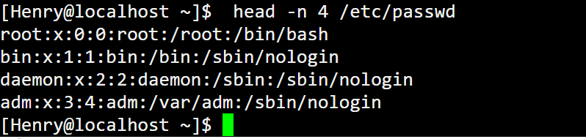
10.Display the last 7 lines of /etc/passwd
